Project Online Component Repository
Distribution
Steering group:
Frank Lüders
Project group:
Vladimir Djukanovic
Cristian Capozucco
Oskar Palmgren
Aleksandar Matovic
Bastien Delbouys
Mohamed Abdi
CONTENTS
1 Introduction 4
1.1 Background 4
1.2 Definitions 4
1.3 Related Documents 4
2 Functional Description 5
2.1 Use Case Model 5
2.1.1 Actors 6
2.1.2 Use Cases 6
2.2 Browse & Search 6
2.2.1 Participating Actors 6
2.2.2 Related Use Cases 6
2.2.3 Precondition 6
2.2.4 Main Flow of Events 6
2.2.5 Alternative: No component found 6
2.3 Inspect Classes & Interfaces 6
2.3.1 Participating Actors 6
2.3.2 Related Use Cases 6
2.3.3 Precondition 7
2.3.4 Main Flow of Events 7
2.4 Download 7
2.4.1 Participating Actors 7
2.4.2 Related Use Cases 7
2.4.3 Precondition 7
2.4.4 Main Flow of Events 7
2.4.5 Alternative: The component is not available 7
2.5 Login 8
2.5.1 Participating Actors 8
2.5.2 Related Use Cases 8
2.5.3 Main Flow of Events 8
2.5.4 Alternative: Invalid information 8
2.6 Register 8
2.6.1 Participating Actors 8
2.6.2 Main Flow of Events 8
2.6.3 Alternative: Invalid information 8
2.7 EditProfil 9
2.7.1 Participating Actors 9
2.7.2 Related Use Cases 9
2.7.3 Precondition 9
2.7.4 Main Flow of Events 9
2.7.5 Alternative: Invalid information 9
2.8 AddComponent 9
2.8.1 Participating Actors 9
2.8.2 Related Use Cases 9
2.8.3 Precondition 9
2.8.4 Main Flow of Events 9
2.8.5 Alternative: <Name of Alternative> 10
2.9 RemoveComponent 10
2.9.1 Participating Actors 10
2.9.2 Related Use Cases 10
2.9.3 Precondition 10
2.9.4 Main Flow of Events 10
2.9.5 Alternative: <Name of Alternative> 10
2.10 EditComponent 10
2.10.1 Participating Actors 10
2.10.2 Related Use Cases 10
2.10.3 Precondition 11
2.10.4 Main Flow of Events 11
2.10.5 Alternative: <Name of Alternative> 11
3 External Interfaces 11
3.1 Graphical User Interface 11
4 Software Architecture 11
4.1 Overview and Rationale 11
4.2 System Decomposition 11
4.3 Hardware/Software Mapping 11
4.4 Persistent Data 11
4.5 Access Control 11
4.6 Synchronization and Timing 12
4.7 Start-Up and Shut-Down 12
4.8 Error Handling 12
5 Detailed Software Design 12
5.1 </Component Name> 12
5.1.1 Static Structure 12
5.1.2 Dynamic Behaviour 12

Introduction

Background
Help: Describe the reasons for the product/component/function to be developed. Also, delineate the purpose of this document and specify the intended audience.
This report describe the design of a software component repository that is a part of the course Component-based Technologies.
The system is a web based system that lets the users browse, search and download component. The system also have administrators that can add, remove and edit information of the components.
The software architecture is a component-based architecture written in C#. Some components must however be written in C++ and Java to access information from COM component and JavaBeans components.

Definitions
Help: List the special terms used, if any. Make references to other documents with definitions.

Terms | Definitions

Related Documents
Help: If applicable, provide a list of documents related to the product/component/function, This could be documents that this document is based on or that explain a specific requirement more in detail. Only include documents that do exist.

Document identity | Document title

Functional Description

Use Case Model
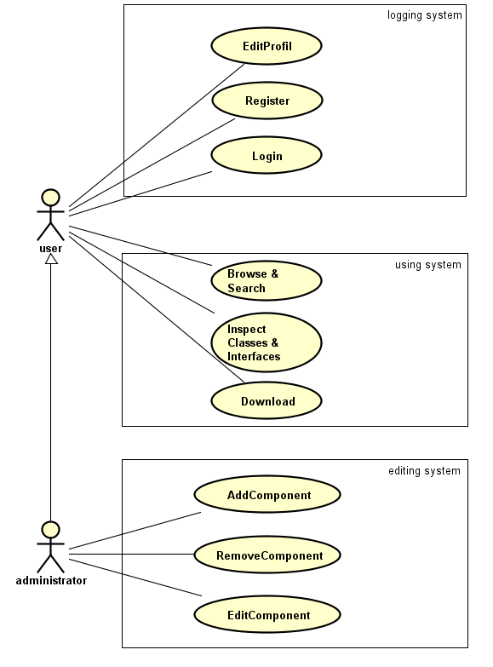
Figure 1 - Use Case Diagram

Actors
Help: Describe the actors in your use case model. Each actor should describe a role an external entity may play when interacting with the system.

Use Cases
Each use case is described in a separate section in the remainder of this chapter.

Browse & Search

Participating Actors
User

Related Use Cases
Login

Precondition
The user has to be logged in.

Main Flow of Events
      - The user search for the name of a component
      - The system looks into the component database for any correspondences
      - The system displays the list of components that match the search

Alternative: No component found
  - At step 2 : If no component match the search
The system displays a message to the user to inform him that no component match the search.
  - Return to step 1

Inspect Classes & Interfaces

Participating Actors
User

Related Use Cases
Login
Browse & Search

Precondition
The user has to be logged in.
The user has to have done a successful search.

Main Flow of Events
- The user selects one of the displayed components.
- The user clicks the “INSPECT” button.
- The system display component’s Classes and Interfaces.
- The user has to clicks the “RETURN” button to end the case.

Download

Participating Actors
User

Related Use Cases
Login
Browse & Search

Precondition
The user has to be logged in.
The user has to have done a successful search.

Main Flow of Events
- The user selects one of the displayed components.
- The user clicks the “DOWNLOAD” button.
- The system checks the availability of the component.
- The system sends the component to the user.

Alternative: The component is not available
  - At step 3 : The component is not available for the download.
The system displays a message telling the user than the component in not available for the download.
  - The system return to the previous user’s search.

Login

Participating Actors
User

Related Use Cases
Register

Main Flow of Events
- The user clicks the “LOGIN” button.
- The system displays a login form (login, password).
- The user completes the form.
- The system checks if the form is valid.
- The user is now logged in, the system displays the user interface.

Alternative: Invalid information
  - At step 4 : Form is not valid, the association login-password is not valid.
The system displays to the user the error.
  - The system brings back the user to the home page.

Register

Participating Actors
User

Main Flow of Events
- The user clicks the “REGISTER” button.
- The system displays a form for the user to complete (login, password).
- The user completes the register form.
- The system checks the validity of the form.
- The system brings back the user to the home page.

Alternative: Invalid information
  - At step 4 : Form is not valid, login already exit, or the password is not valid.
The system displays the error committed by the user in the form.
  - Return to step 2.

EditProfil

Participating Actors
User

Related Use Cases
Login

Precondition
The user has to be logged in.

Main Flow of Events
- The user clicks the “EDIT” button.
- The system displays a form to the user (old password, new password).
- The user fills the form.
- The system check if the form is valid.
- The system brings back the user to the home page.

Alternative: Invalid information
  - At step 4 : Form is not valid, the old password is incorrect or the new one is not valid.
The system displays to the user the error.
  - Return to step 2.

AddComponent
This use case is responsible for adding components to the repository and displaying a component in the UI if the upload was successful.

Participating Actors
The initiating actor is administrator and only the user with admin privileges can perform this use case.

Related Use Cases
Based on the belonging subsystem the related use cases is/are:
- Remove Component and
- Edit Component
Based on the preconditions the related use case/s is/are:
- Login

Precondition
User has to be logged in.

Main Flow of Events
      - The administrator initiates to add the component (by pressing a button etc.)
      - The system gives the user the form to upload component
      - The administrator fills the form and press the upload button
      - The system checks the validity of form
      - The system stores the component in the database
      - The system displays newly added component
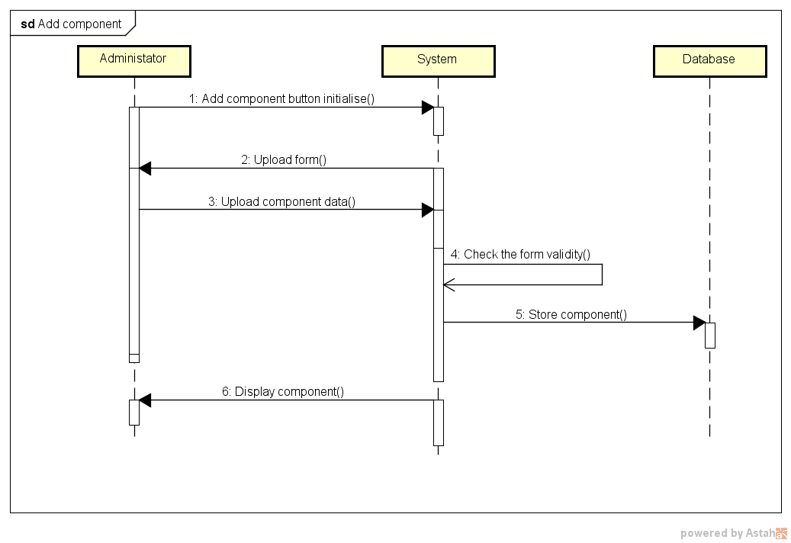

Alternative: The upload component form is invalid
  - At step 4: Form is not valid, all data not provided or invalid data.
The system displays the error committed by the user in the form.
  - Return to step 3
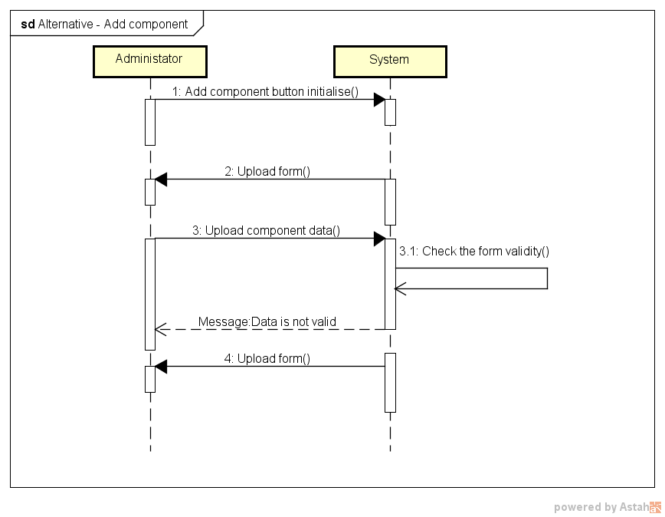

RemoveComponent
This use case is responsible for removing components from the repository and updating UI if the removal was successful.

Participating Actors
The initiating actor is administrator and only the user with admin privileges can perform this use case.

Related Use Cases
Based on the belonging subsystem the related use case/s is/are:
- Add Component and
- Edit Component
Based on the preconditions the related use cases is/are:
- Login

Precondition
User has to be logged in.

Main Flow of Events
      - The administrator selects the component and clicks remove button
      - The system asks for confirmation to remove selected component
      - The administrator clicks to confirm removal
      - The system removes the component from database
      - The system updates UI
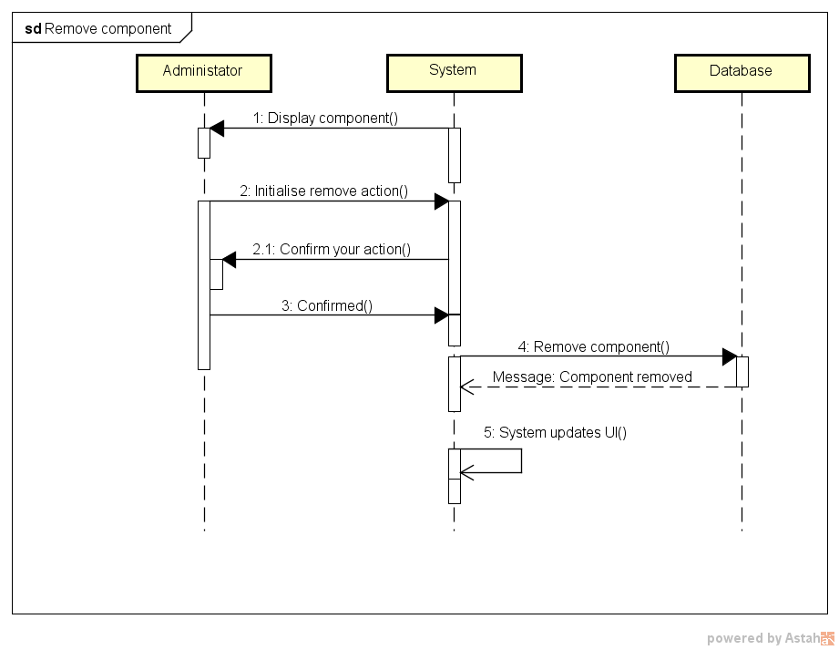

Alternative: Cancel confirmation panel for component removal
  - At step 3: The administrator clicks to cancel component removal
The system closes the confirmation panel.
  - The system returns to home page.

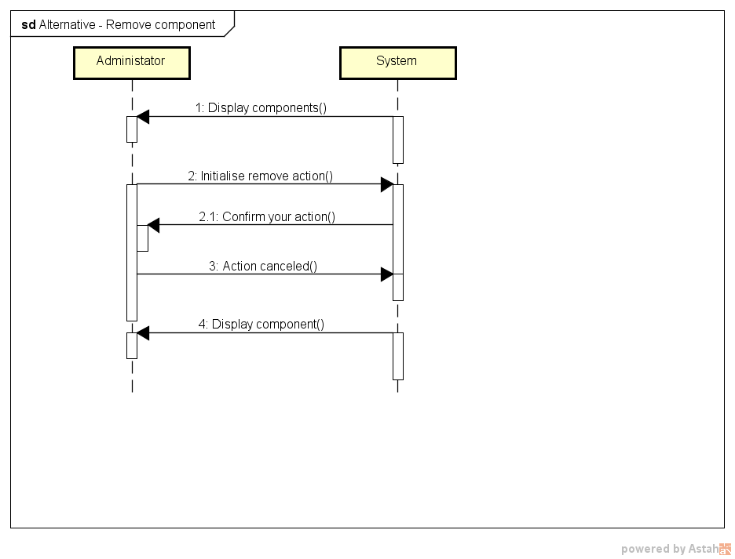

EditComponent
This use case is responsible for editing component information and therefore updating the repository and UI if the editing was successful.

Participating Actors
The initiating actor is administrator and only the user with admin privileges can perform this use case.

Related Use Cases
Based on the belonging subsystem the related use cases is/are:
- Remove Component and
- Remove Component
Based on the preconditions the related use case/s is/are:
- Login

Precondition
User has to be logged in.

Main Flow of Events
      - The administrator clicks the edit button for specific component
      - The system gives administrator the form to edit component information
      - The administrator changes the form and clicks to update component information
      - The system checks the validity of the form
      - The system updates the component in the database and updates UI
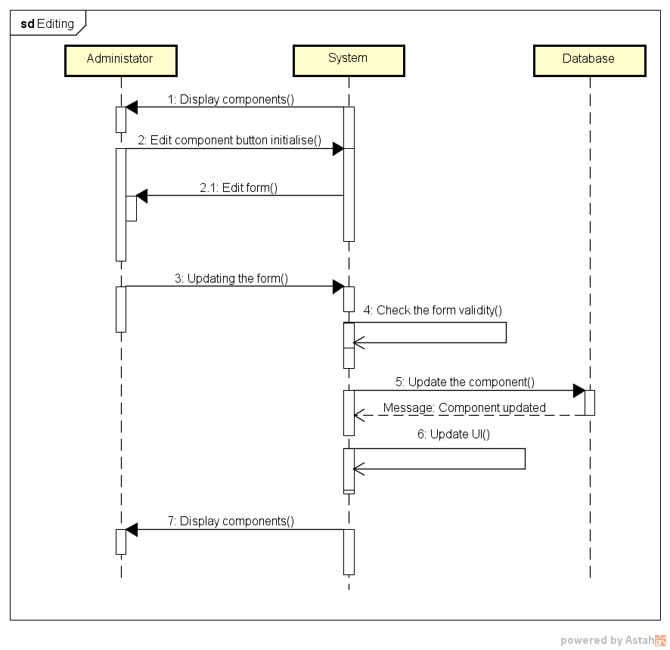

Alternative: The updated form is invalid
  - At step 4: Form is not valid, all data not provided or invalid data.
The system displays the error committed by the user in the form.
  - Return to step 3
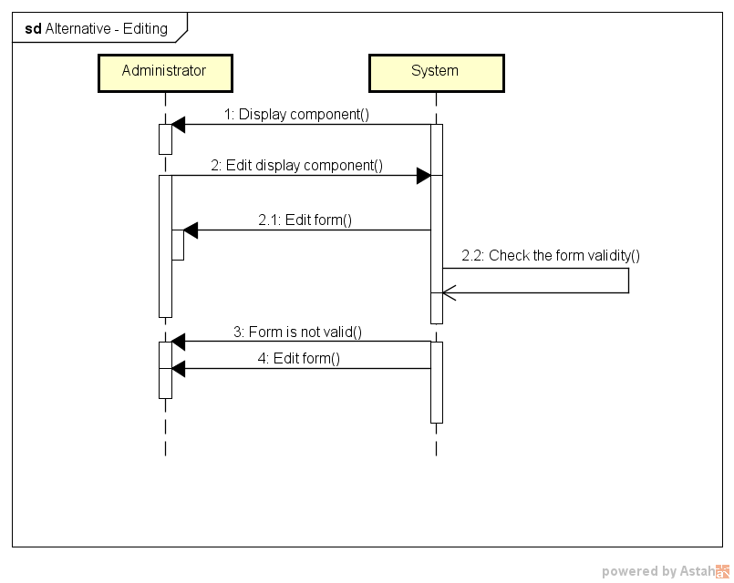

External Interfaces
Help Describe the interface(s) to users and other external entities.

Graphical User Interface
Help Omit if not relevant. Otherwise describe the structure and general layout of the interface using subsections and figures as appropriate.
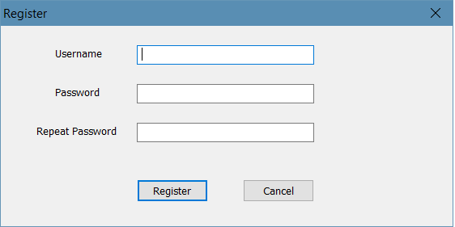
Figure 2 - Register form
In the Figure 2 is showed the register form: this dialog will appear every time a new user need to register in the system. There are 3 simple text box: one for the username and two for the password. Of course, the user can then register through the Register button or cancel the registration by closing the dialog or by pushing the Cancel button.

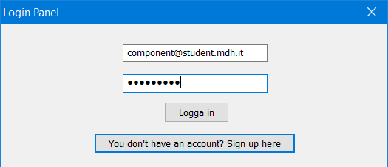
Figure 3 - Login form
Through this dialog, a user can log in the system by inserting his credentials (username and password) or creating a new account by clicking the second button.
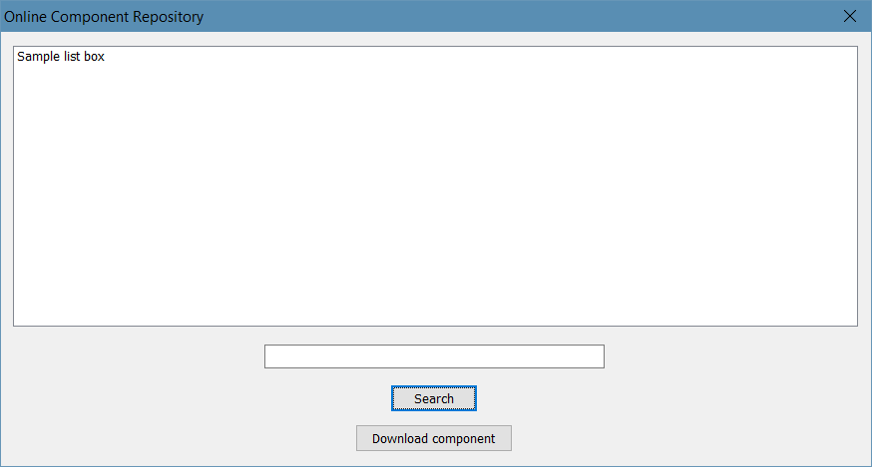
Figure 4 - Main user interface
This is the main interface for the user: there is a big listbox in which ALL THE COMPONENTS are showed, than a little textbox in which the user can insert the name of a component and search for it. If a component is selected, the user can press the Download Component button in order to download it
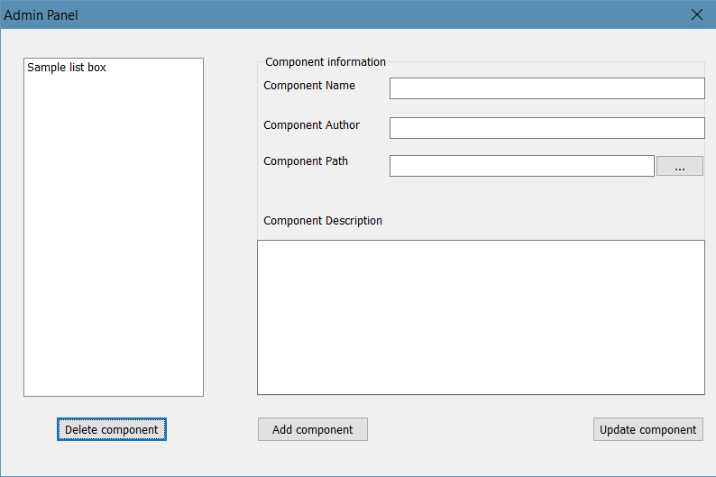
Figure 5 - Admin Panel
If a user is an administrator of the system, then he can access this panel. On the left, a list box shows every component registered in the system. If the admin selects one of them and clicks the Delete component button, then the component is deleted from the system. If a component is selected, then every information regarding it are showed in the textboxes on the right and the admin can update them by pushing the Update component button. If no component is selected, then the admin can fill every textbox in order to register a new component by pressing the Add component button.

Software Architecture

Overview and Rationale
Help Give a short overview of the architecture and its rationale. Mention any architectural styles or strategies you have used.

System Decomposition
Help Present the decomposition into components and the purpose of each.

Hardware/Software Mapping
Help Describe how components are assigned to hardware and off-the-shelf software components.

Persistent Data
Help Describe what persistent data is managed by the system and how this is done.

Access Control
Help If relevant.

Synchronization and Timing
Help If relevant.

Start-Up and Shut-Down
Help This is always relevant.

Error Handling
Help This is always relevant.

Detailed Software Design

</Component Name>
Help Add a section for each component. Add subsections as appropriate in each case.

Static Structure
Help Show the classes in the subsystem and relationships between them using a UML class diagram. Describe the purpose of each class briefly.

Dynamic Behaviour
Help Describe object interactions using UML sequence diagrams. You may also describe behaviour of nontrivial classes using state diagrams.

REVISION
Rev.  Ind. | Page (P)  Chapt.(C) | Description | Date  Initials

